Table of Contents
Page
Purpose. . . . . . . . . . . . . . . . . . . . . . . . . . . . . . . . . . . . . . . . . . . . . . . . . . . . . . . . . . . . . . . . . . . . . . . . 1
How to use. . . . . . . . . . . . . . . . . . . . . . . . . . . . . . . . . . . . . . . . . . . . . . . . . . . . . . . . . . . . . . . . . . . . . 2
Changing myRIO target . . . . . . . . . . . . . . . . . . . . . . . . . . . . . . . . . . . . . . . . . . . . . . . . . . . . . . . . . . . 3
Controls ... . . . . . . . . . . . . . . . . . . . . . . . . . . . . . . . . . . . . . . . . . . . . . . . . . . . . . . . . . . . . . . . . . . . 4 - 7
Troubleshooting. . . . . . . . . . . . . . . . . . . . . . . . . . . . . . . . . . . . . . . . . . . . . . . . . . . . . . . . . . . . . . . . . 8

Purpose
The LabVIEW scope is to be used as both a diagnostic and data collection tool for National Instruments myRIO. It can be used to test servo and DC motors, output a specified signal, and read in and display analog signals.

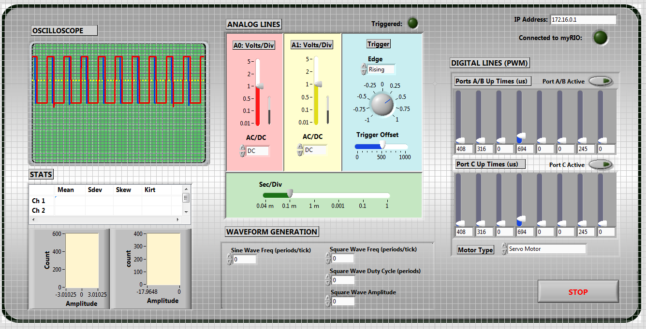
The Scope Demo VI front panel

How to use
The scope code consists of two main parts: the Scope Server VI and the Scope Demo VI. The Scope Server runs on the myRIO device, and the Scope Demo runs on the user’s computer. The two VIs communicate via a TCP (Transmission Control Protocol) connection.
To begin, open up the Scope Demo on your computer.
The Scope Server should automatically run as a startup VI on the myRIO once it is plugged in to a power source.
By changing the controls on the Scope Demo, information is relayed to the Scope Server on the myRIO, which then performs the specified actions.
This two-VI system is necessary because there are no LabVIEW myRIO controls for Mac, so Mac users would need to use a virtual machine to use the code, which can be a pain.
IP address:
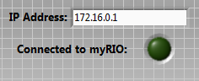
IP address control and myRIO connection indicator
The IP address control is located in the top right corner of the Scope Demo VI. Enter the IP address of the target myRIO into the input box. If the VI successfully connects to the myRIO, the “Connected to myRIO” indicator will light up.

Changing myRIO Target:
- Right click on the myRIO target
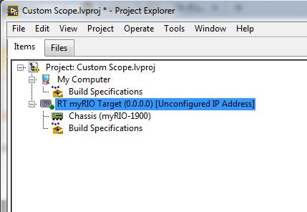
- Select “properties”
- Enter the name and IP of your myRIO
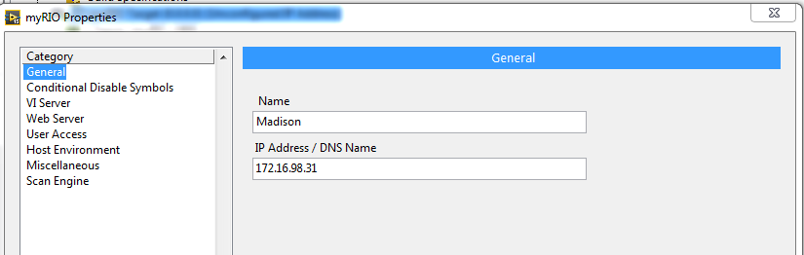
- Check connection by right clicking the myRIO target again and selecting “connect”

Controls
Analog (Scope) Controls:
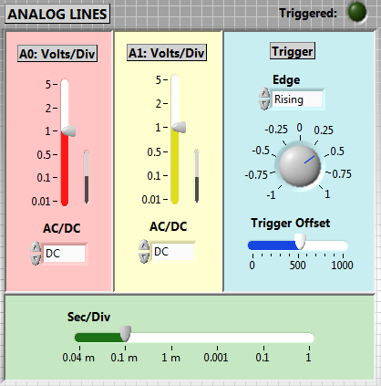
Analog (scope) controls
The analog (scope) controls contain typical controls that you’d find on an oscilloscope.
The large red and yellow vertical sliders under “A0: Volts/Div” and “A1: Volts/Div” control the scaling of the vertical axis for the two input channels (port A, inputs 0 and 1). The smaller black bars next to them control the vertical offset of the signals.
The “AC/DC” dropdown menus below them control the type of signal that is read in through each channel.
The blue box contains information about the trigger. The “Edge” dropdown menu specifies the trigger edge to be used. The dial control below it specifies the trigger. The green “Sec/Div” slider at the bottom controls the horizontal scale.

Digital controls:
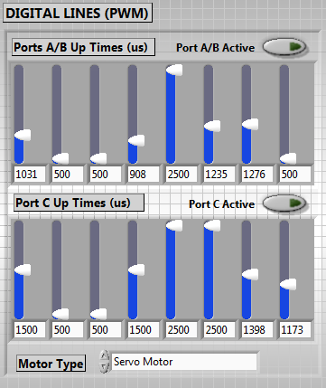
Digital PWM controls
The digital controls control PWM signals to the digital pins on the myRIO. The “Port A/B Active” and “Port C Active” buttons control which pins the signals are sent to. Note that ports A and B are grouped together, so either both A&B being sent signals or neither is being sent signals, and the signals they receive are the same.
For each option, there are 8 vertical sliders, which range from 500 to 2500. These sliders represent the up times (in microseconds) for the output PWM signals. From left to right, these sliders control the PWM signal for digital pins 0 through 7 for the ports.
The dropdown box at the bottom specifies the motor type being used. There are options for a servo motor and a DC motor.

Waveform generation:
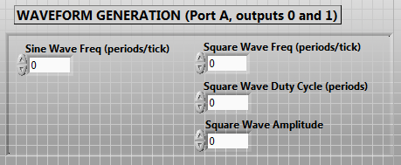
Waveform generation controls
The waveform generation controls control the analog waveform output signals from the myRIO. There are two outputs: a sine wave and a square wave. Both signals are come out of port A. The sine wave comes out of analog output 0, and the square wave comes out of analog output 1. Only the frequency of the sine wave can be controlled. The frequency, duty cycle, and amplitude of the square wave can be controlled.
Stopping the VI:
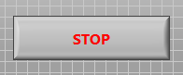
Stop button
The stop button is located in the bottom right corner and stops the VI.

Oscilloscope and Statistics:
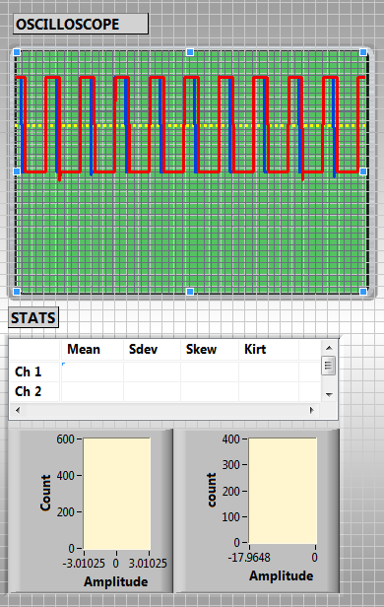
The oscilloscope graph and statistics

The oscilloscope displays the signals read in, with the settings specified in the analog controls area. From these signals, some basic statistics are computed and displayed in the “Stats” section.

Troubleshooting
The Scope Demo won’t connect to the myRIO
- Make sure that the IP address on the Scope Demo matches the IP of the myRIO. You can check this by using NI MAX (National Instruments Measurement and Automation eXplorer) under “Remote Systems”. The IP address should be shown when you click on the name of the device you’re using in the list of remote systems.
- Make sure that the Scope Server is running on the myRIO. It should be deployed as a startup application, but if it isn’t for some reason you’ll need to redeploy it. If you’ve run another VI on the myRIO since it was powered on, you’ll need to unplug and replug it in to restart it, and the Scope Server should run on startup.
- Sometimes it takes a little while to connect. Give it a good 10-15 seconds after running the Scope Demo to see if it connects.
- If you’re connecting the myRIO wirelessly, make sure that the LED next to the WiFi symbol is lit (indicating that the myRIO is successfully connected wirelessly). If it isn’t lit up, the WiFi connectivity capability of the myRIO may be disabled. To enable it, press the button at the bottom edge of the myRIO with the WiFi symbol next to it.

I can’t connect to/find the myRIO on my computer
- If you’re connecting the myRIO wirelessly, make sure that the LED next to the WiFi symbol is lit (indicating that the myRIO is successfully connected wirelessly). If it isn’t lit up, the WiFi connectivity capability of the myRIO may be disabled. To enable it, press the button at the bottom edge of the myRIO with the WiFi symbol next to it.
- If the device isn’t showing up in NI MAX (see “The Scope Demo won’t connect to the myRIO” section in Troubleshooting), try plugging the device in to your computer via a wired (Ethernet) connection. If you’re already using a wired connection, try unplugging and replugging. If the device still doesn’t show up in NI MAX, try restarting your computer.
- Make sure the myRIO is connected to a power source. If it is, the LED next to “Power” should be on.

